1) Created a GitHub Account
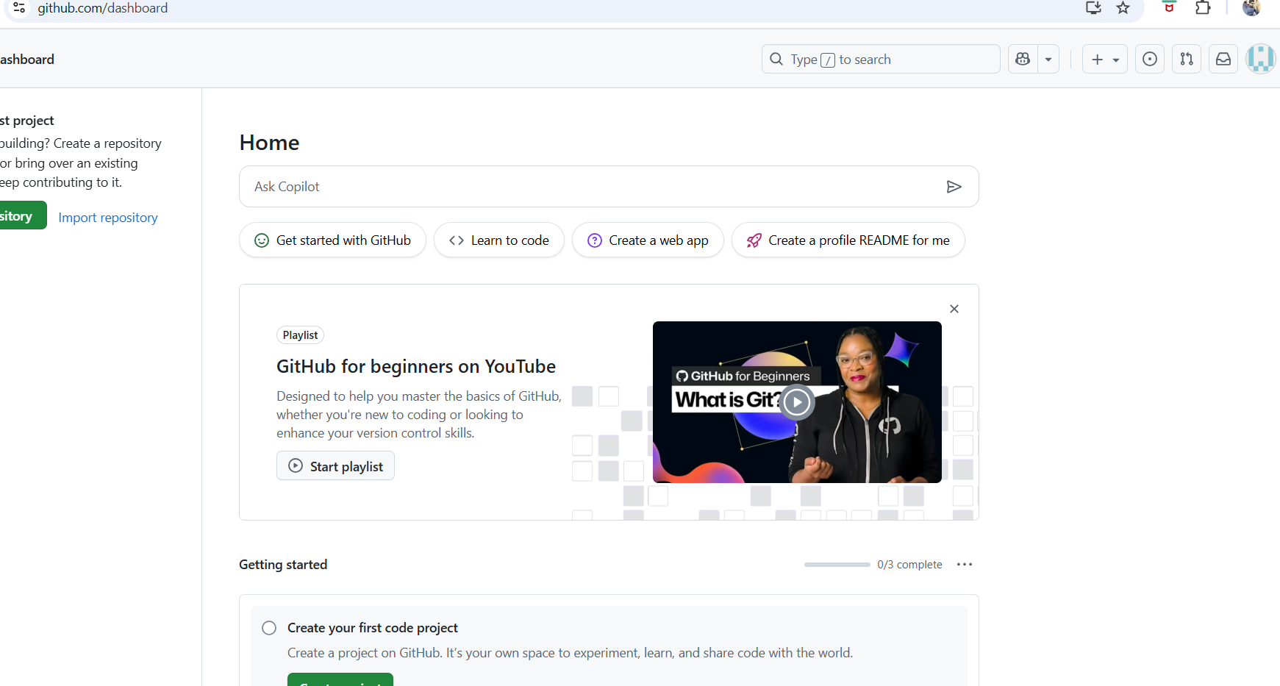
2) Multi factor authentication
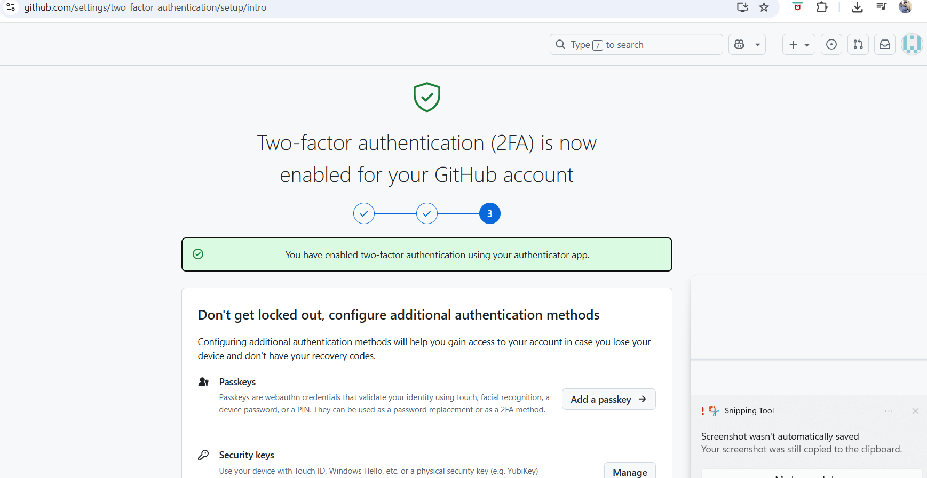

$git init – to initialize the .get file
$cd .get/ to check the .get config files

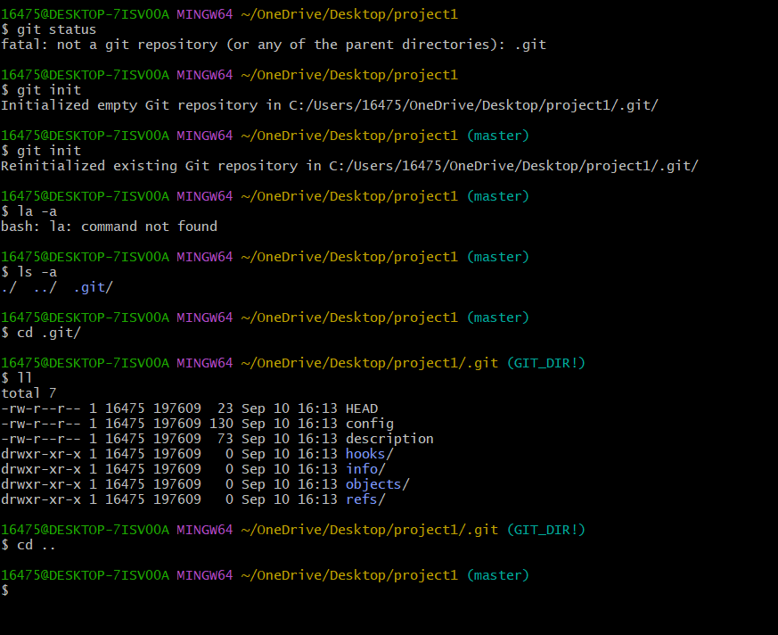
$touch a – created “a” file in local repository
$touch dockerfile -created “dockerfile” in local repository
$git status – to check the whether files in tracking or untracking area

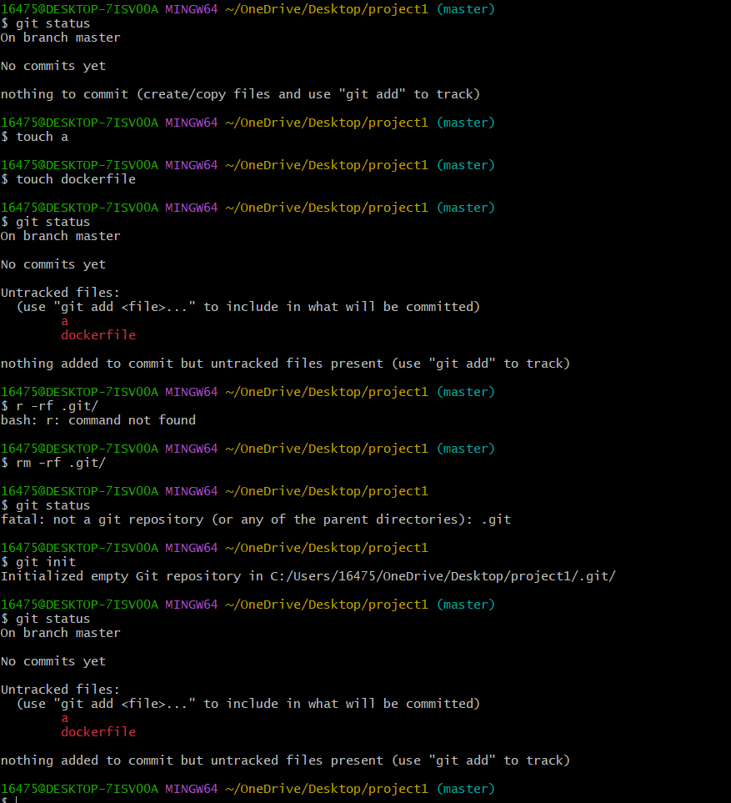
$git config –list
$git config –-global user.name “Akhil”
$git config –global user.email akhilgoud1010@gmail.com
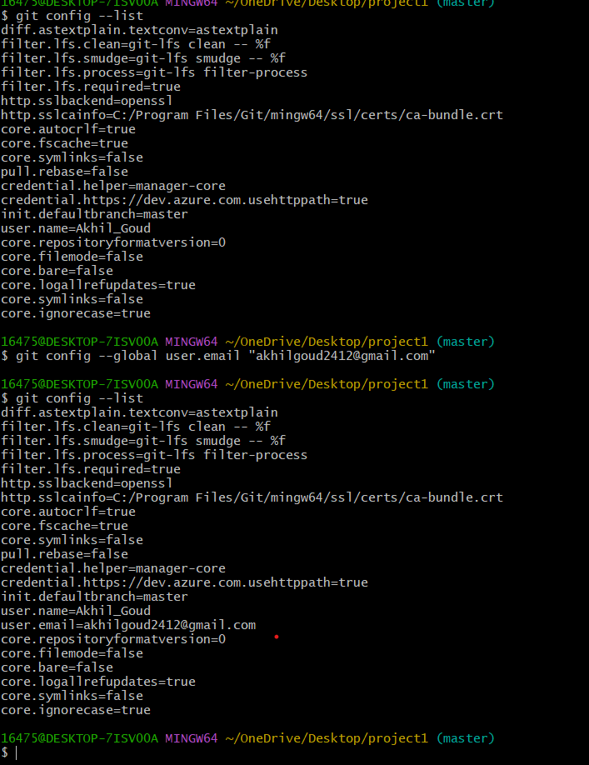\
$git add a dockerfile
$touch a b c d -created more files in the local repository
$git add . ----added all the files to tracking area
$git status-to check the status of the files
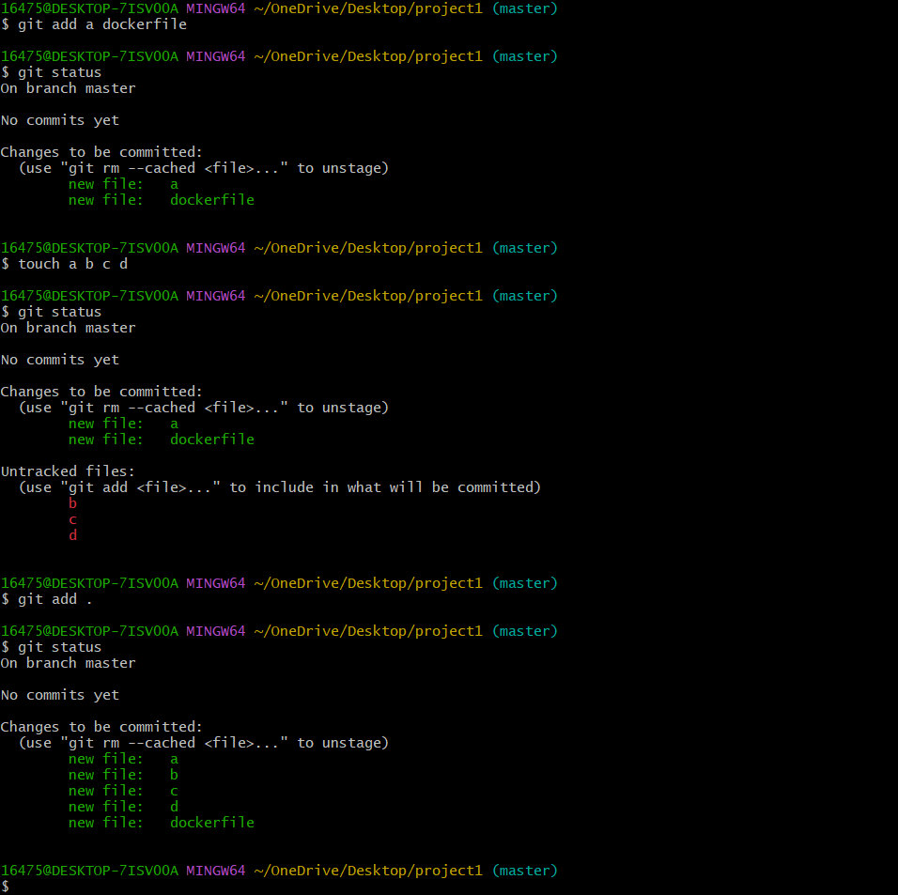
$git commit -m “added couple of files”
$git log to check recent recently committed files along commit id
$ls -
$touch e –created another file “e”
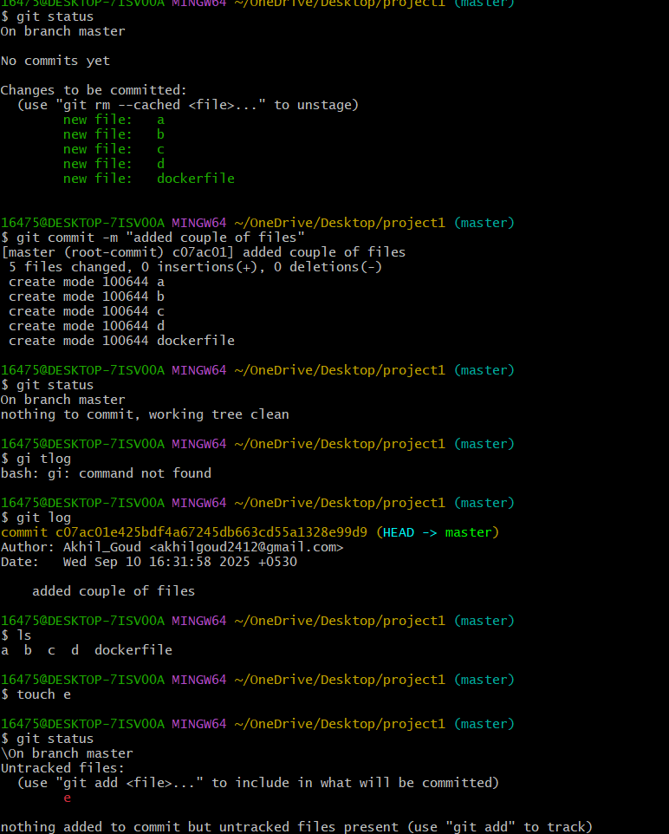
$git add . ---- added file “e” to the tracking area
$git status ------ to check the whether files in tracking or untracking area
$git commit -m “added e file to the project”
$git status ----- to check the whether files in tracking or untracking area
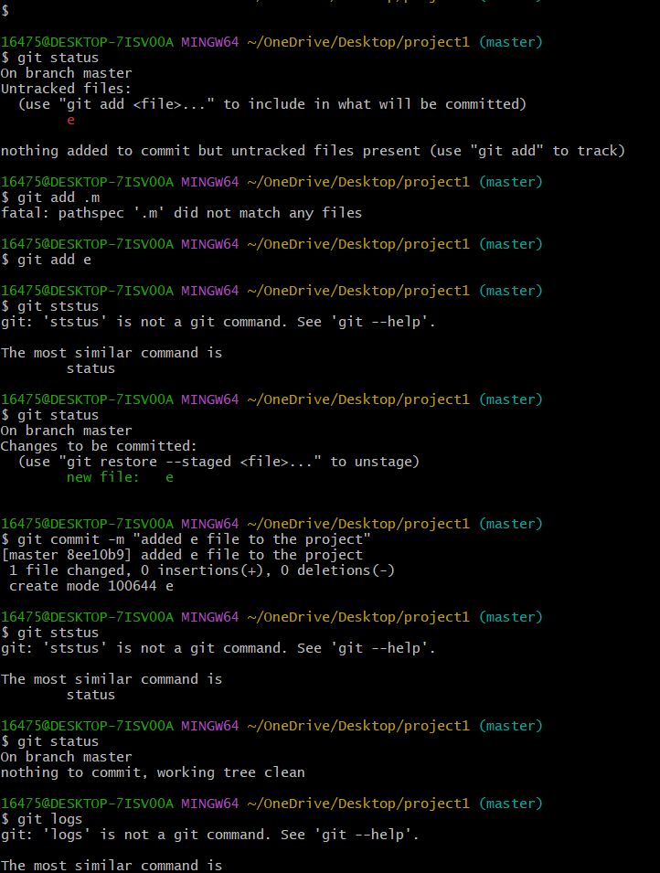
$git remote -v
$git remote add origin git @github
$ssh-keygen -to copy the key path in the github /central repository
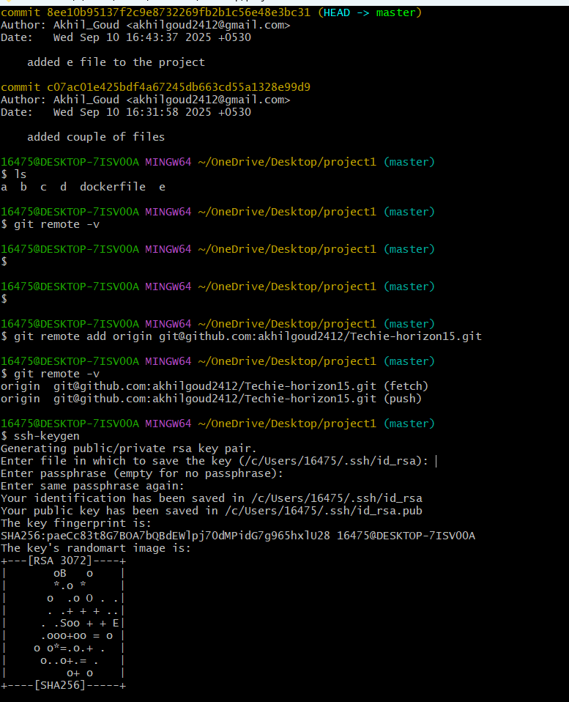
$cat key and copy in github ssh key
$git push -u origin master -to push the files from local to central repository
$rm dockerfile -to remove the dockerfile
$ls—long list to check whether dockerfile is available or not
$git status --- to check the whether files in tracking or untracking area
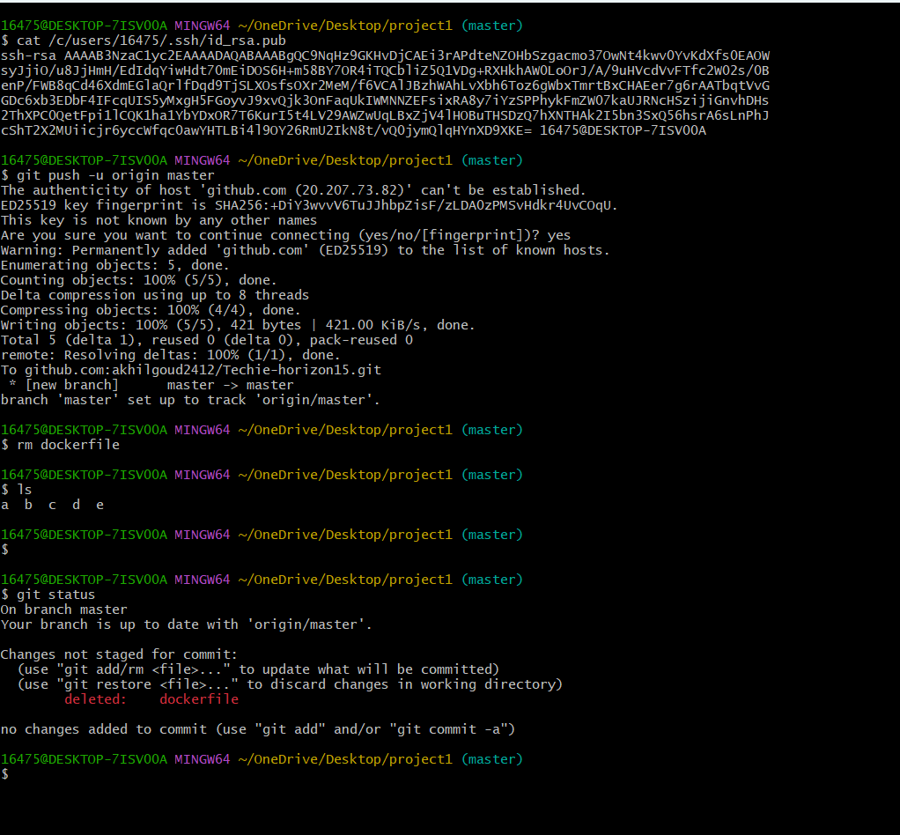
$git add . ---
$git commit -m “deleted dockerfile”
$git push -u origin master
$ls
$touch abc
$git add .
$git commit -m “added a file abc”
$git push -u origin master
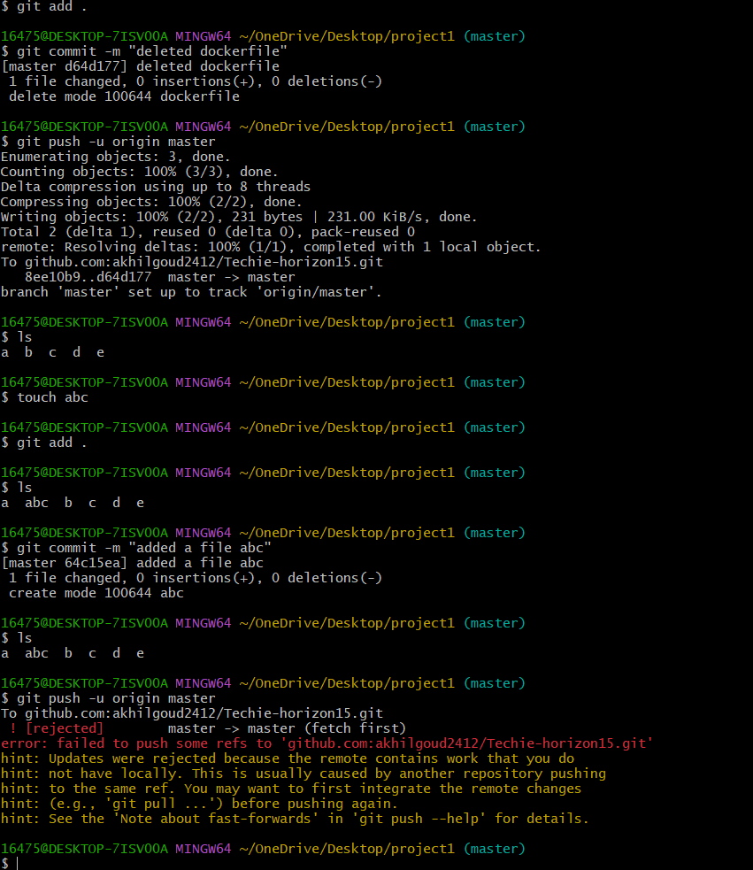
$git pull----to pull the changes made directly in central repository
$git push -u origin master –again pushing the files into central repository
$git clone ssh path ----
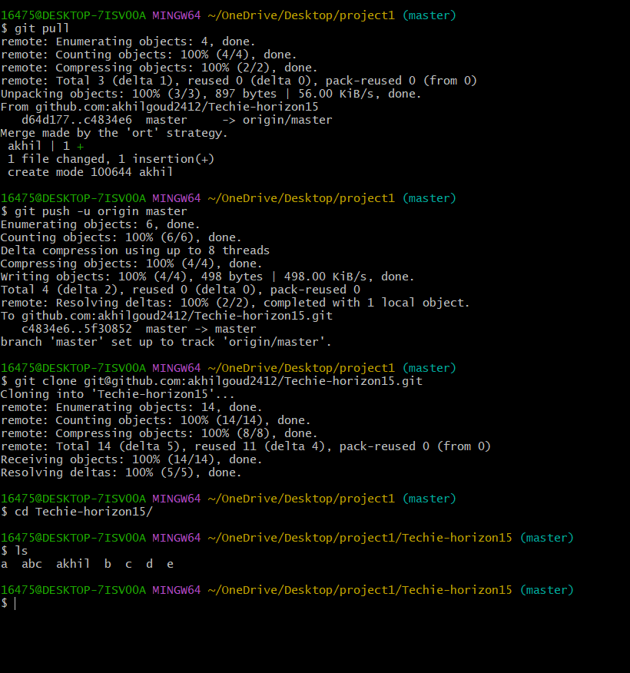
$git log ---to check the recently made commits along with commit ID
$git revert commit id----to revert the commit

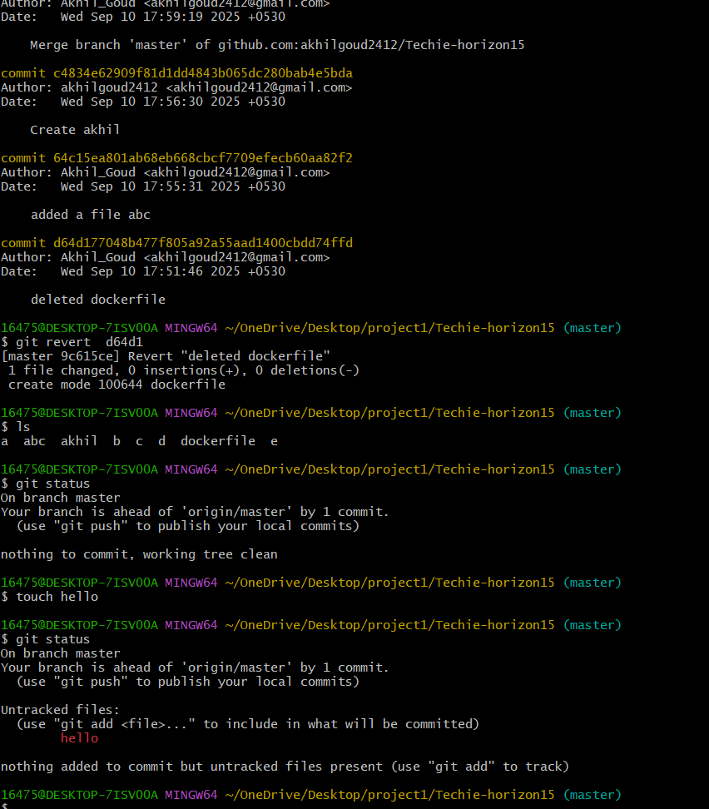
$git status
$git add .
$git status
$git reset
$git status
$git add .

